**WIGGINTON PARISH COUNCIL** WARDEN UPDATE: **AUG/SEPT 2024**

|  |  |
| --- | --- |
| **AREA** | **SPORTS FIELD** |
| **TO CHECK** | Gym/Sports equipment, Children’s playground, Car Park, Trees & vegetation, Notice board, Safety Information, Fencing, Gates, Wooden bollards, Benches, Picnic Tables, Grass height, General ground conditions, Litter and Dog waste bags. |
| **INSPECTION DATES** | 12/8, 19/8, 26/8, 2/9, 9/9 |
| **ISSUES TO REPORT** | 1. A weekly litter pick was conducted. 2. Grass height is meeting the mowing specification. 3. The hedge running parallel with Wick Road has been neatly cut, both sides and top (Photos 1 & 2) 4. A deep hole where a football goalpost previously stood has been filled. 5. Fitness machinery was visually checked and found to be operating correctly. Two defects were observed.  * User/safety information is needed on the double sit up boards - existing signage is no longer clear (Photo 3). * A plastic cover is missing from a bolt head at the base of the exercise bike (Photo 4). This represents a minimal risk.  1. The playground has recently been renovated. The renovation includes new swings, new solid rubber surfaces, new climbing frame, replacement playhouse steps, and various important repairs (Photo 5). 2. Dog poo bag dispensers were replenished as needed. 3. All outdoor furniture remains in fair order. 4. Golf related occurrences have increased in recent weeks. Should a golf ball hit a person an acute injury may be sustained including contusions and skull fractures. WPC may wish to explore risk-reduction action i.e. prohibition, signage. 5. Fly tipping (wire mesh fencing) discarded by the car park entrance has been reported to DBC. Ref no: 908963.   **Outstanding items**   * Memorial bench needs refastening to the ground. * Cabinet holding football equipment remains insecure following vandalism. * Defective section of playground fencing (please see recent report issued by The Play Inspection Company). |

|  |  |
| --- | --- |
| **AREA** | **RECREATION GROUND** |
| **TO CHECK** | Fencing, Benches/seats, Trees & vegetation, Grass height, Car Park, Litter & Dog waste bins. |
|  | 12/8, 19/8, 26/8, 2/9, 9/9 |
| **ISSUES TO REPORT** | 1. Weekly litter picking was conducted. 2. All outdoor furniture remains in fair condition. Racial/Offensive graffiti was removed from a bench and nearby street nameplate. 3. Dog poo bag dispensers were replenished. 4. Grass height, including the wilded area, complies with the annual maintenance agreement. 5. Boundary hedges have been successfully cut in accordance with the maintenance agreement (Photo 6). This includes the hedge bordering The Hollies.   **Outstanding item**   * Benches need refixing to the ground to prevent overturning. * A replacement dog poo dispenser is missing (Highfield Road entrance). Parish Clerk has ordered a replacement dispenser. |

|  |  |
| --- | --- |
| **AREA** | **HIGHWAY’S, PUBLIC FOOTPATHS & DITCHES** |
| **TO CHECK** | Surfaces, Pedestrian routes, Signage inc. finger post, Bench (Oddy Hill), Drainage, Grit bins, Litter, Bollards, Footpaths/Kissing gates, Notice boards, Defibrillator |
| **DATES** | 12/8, 19/8, 26/8, 2/9, 9/9 |
| **ISSUES TO REPORT** | 1. The defibrillator was visually checked. Disconcertingly, the battery is extremely low at 33% (Photo 7). Essential accessories were found inside the cabinet, including a guidance card. 2. Litter picking was conducted in the village centre, Vicarage Road, Fox Road, Wigginton Bottom, The Twist, and Hemp Lane. 3. A TV ariel fly-tipped in Highfield Road has been collected by DBC. Ref No: 900383. 4. Following forced entry, the Smith Coaches main garage door is again securely padlocked (Photo 8). 5. Pothole next to a drain in Vicarage Road has been repaired. HCC Ref No: 401004304697 (photo 9). 6. A sign alerting road users to an approaching junction (Crawley’s Lane) has been knocked over in Chesham Road (Photo 10). HCC advise the sign will be reinstated once funds permit. Ref no: 401004304694. 7. Dense and overrun vegetation at the bottom of The Twist has been cleared by HCC. Ref no: 401004253084. 8. Overgrown vegetation in Fox Road, near the Firs, has been cut back by HCC. Ref no: 401004253074. 9. Pothole near St Barthlomew School has been reported to HCC. Ref No: 401004326954 (Photo 11). 10. Overgrown vegetation needs clearing back ideally to the fence-line between the Greyhound PH and Sports Field entrance (Photo 12).   **Outstanding items (HCC).**   * Damaged directional sign – Chesham Road/Vicarage Road junction. HCC ref no: 401003790025. * Blocked drain in Hemp Lane opposite property Kirkdale. Ref No: 401003596160. |

**PHOTOGRAPHS**

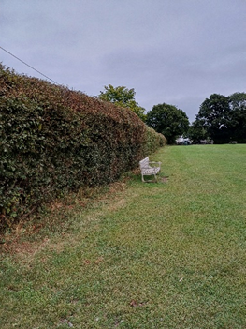 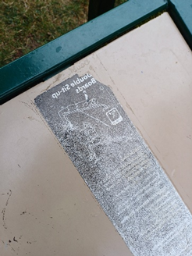

3

2

1

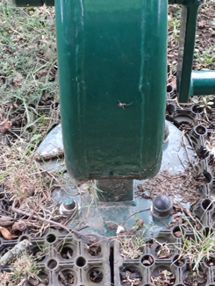 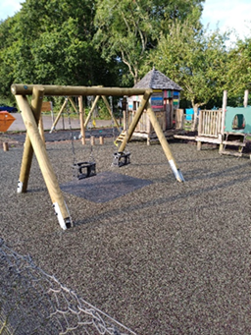 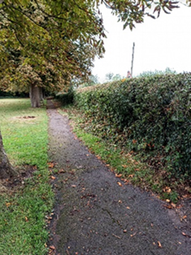

6

5

4

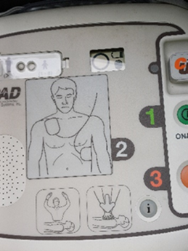 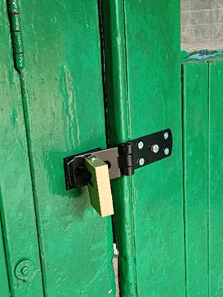 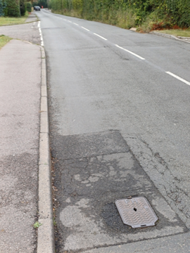

9

8

7

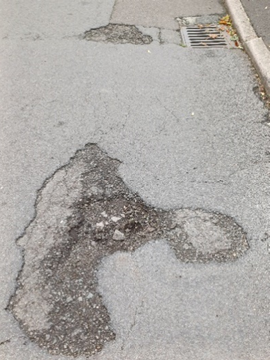 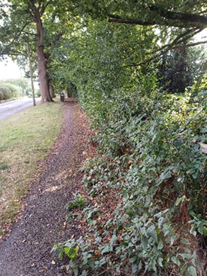

12

11

10